South Ribble Council

Final
Internal Audit Report

Water Management
2022/2023

Audit Assurance: Limited
Auditor: Linsey Roberts
Date Issued: 15.5.2023

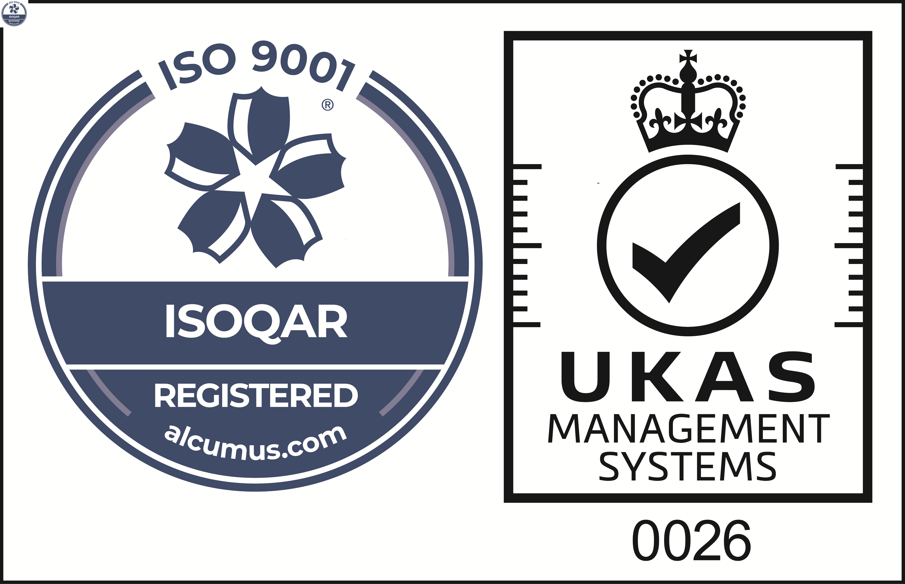
Cert No: 20128
ISO 9001

 | Reason for the Audit & Scope
1 | Water management refers to the development, monitoring and management of water sites and areas that are the responsibility of the Council.  This also encompasses the consideration of liability risks of the Council responsible for land on which a water feature site exists; those risks being to the public, employees, contractors and service providers working on or near water. The principle is that water areas are maintained and managed in as safe an order as is practically possible.  The review is included in the 2022/23 Annual Audit Plan approved by the Governance Committee in September 2022.

 | Audit Objectives
2 | The overall objective of the audit was to provide an opinion of the adequacy, application and reliability of the key internal controls put in place by management to ensure that the identified risks are being sufficiently managed.
3 | The audit also assessed the effectiveness of the various other sources of assurances using the three lines of defence methodology.

 | Audit Assurance
4 | Water Management at South Ribble Borough Council has not been reviewed by Internal Audit previously.
5 | The Head of Internal Audit is required to provide the Governance Committee with an annual audit opinion on the effectiveness of the overall control environment operating within the Council and to facilitate this each individual audit is awarded a controls assurance rating. This is based upon the work undertaken during the review and considers the reliance we can place on the other sources of assurance.
6 | Appendix A shows the risks that have been tested for Water Management and the assurance opinion awarded to each. Our evaluation of the reliance we can place on the three lines of defence is also shown.
7 | Our work established that there is evidence of awareness of the risks posed by the activities that are undertaken around areas of water. Some risk management measures are in place to reduce the risk to the public and employees/contractors working on-site, for instance Neighbourhood Officer site inspections and lifeline checks are carried out.  Neighbourhood Officers are experienced and there is good evidence of team working to identify and address site issues/hazards. In addition, work is currently in progress to identify and document all areas of water, reviewing sufficiency of current on-site safety signage/equipment (renewing and improving as required).  However, the following significant management issues related to the management of water sites were identified:  - The Council does not have a water management/safety policy in place, setting out the reasoning behind the provision of access to the water areas, the legal/statutory obligations and how risks are managed. There is a lack of documented evidence to support that a risk-based approach is in place with regards to the frequency of inspections, categorisation of maintenance and defects to ensure remedial action is taken in accordance to the level of risk;  - A comprehensive list of water sites is not in place, so we are therefore unable to provide assurance that all water bodies have been identified and are being actively inspected. Whilst water bodies are listed on the database currently in use, there are known issues with this system as identified in the Neighbourhood Records report issued by Internal Audit in 2021.  - Site risk assessments that inform the nature and frequency of inspection for each site are not in place for all areas of water. It is important that local knowledge is used to identify/document/manage the hazards specific to each area, for instance times of heavy use, impact of the weather, previous incidents and anti-social behaviour issues etc.  - There is a lack of guidance/operating procedures for the Neighbourhood Officers undertaking site inspections, for instance what is included, definitions, recording the result and subsequent action to take if a defect is identified.  - Supervisory monitoring is not carried out to confirm that the inspection regime is working as intended.  To reduce the likelihood of harm to employees and to ensure that the Council meets its obligations under the Health & Safety at Work Act 1974, it needs to ensure that any Health and Safety risks have been identified and suitable safe systems of work have been adopted.  Whilst a generic working near water risk assessment is in place, further work is required as the risks and controls are not site specific and are not reflective of the individual conditions and the full range of hazardous activities undertaken for each body of water. Furthermore, volunteers lone working arrangements have not been assessed at the Longton Brickcroft Nature Reserve.  The Service is currently in a period of transition with the imminent implementation of Alloy Asset Management System. All assets, including water bodies are currently being identified and will be plotted on the system. The introduction of this system will improve agile working and automate the inspection and maintenance regime, however until this is fully implemented the risks identified above remain.  As these highlight significant risks in relation to lack of policy, risk assessment, health & safety, and could lead to potential negative repercussions for the Council. a Limited assurance rating has been awarded for this review. The action plan at Appendix B provides further details of the findings and risks identified.  Control Rating Key  Full – the Authority can place complete reliance on the controls. No control weaknesses exist.  Substantial - the Authority can place sufficient reliance on the controls. Only minor control weaknesses exist.  Adequate - the Authority can place only partial reliance on the controls. Some control issues need to be resolved.  Limited - the Authority cannot place sufficient reliance on the controls. Substantive control weaknesses exist

Risk and Controls | Control Evaluation
Risk 1 – Relevant policies and procedures are not communicated effectively to employees, leading to confusion re roles & responsibilities
Policy/Strategy is in place and approved | Action 1
Flood Risk Management is adequately managed | Working as intended
Policy/Strategy is up to date, owned and reviewed regularly | Action 1
Policy/Strategy is suitable/fit for purpose (Legislation) | Action 1
Policy/Strategy is accessible/staff awareness of policy | Action 1
Procedure/working practices are in place | Actions 2, 3
Risk 2 – Legal and statutory requirements may not be being met due to ineffective management of water sites.
Policy/Strategy is suitable/fit for purpose (Legislation) | Action 1
All open water sites have been identified | Action 4
Inspection programme in place | Actions 5, 6, 7
Comprehensive records are maintained | Action 2, 4, 5, 6, 7
Supervisory checks undertaken | Action 8
Health & Safety (employees and volunteers) | Action 9,10,11
Signage has been considered for each site | Action 5
Rescue Equipment | Action 5
Fishing club use managed and licensed | Working as intended
Risk 3 – A failure to recognise all existing water site assets meaning that some may fall into disrepair or become dangerous
Procedure/working practices are in place | Actions 2, 3
All open water sites have been identified | Action 4
New site identification | Working as intended
Inventories are in place to manage assets at each site | Action 2,4,5,6,7
Inspection programme in place | Actions 5, 6, 7
Risk 4 – A lack of maintenance of water areas to prevent them from becoming hazardous
Procedure/working practices are in place | Actions 2, 3
Responsibilities are clearly defined | Action 1, 3,5,6,7
Inspection programme in place | Actions 6, 7
Regular/planned maintenance and reactive maintenance | Action 7
Comprehensive records are maintained | Action 2, 4, 5, 6, 7
Supervisory checks undertaken | Action 8
Risk 5 - Potential lack of adequate staff training for appropriate roles covering water areas
Supervisory checks undertaken | Action 8
Training matrix helps identify any gaps | Working as intended
Officers are First Aid trained | Working as intended
Risk 6 - Inadequate insurance cover meaning that the Council’s legal obligations cannot be met
Insurance policy in place | Working as intended
Awareness of risk management requirements | Action 1, 2, 3, 5,9,12
Risk 7 - Risks for each water site have not been identified, recorded and monitored adequately – including health and safety risks, injury risks and emergency procedures
Inventories are in place to manage assets at each site | Action 2,4,5,6,7
Health & Safety (employees and volunteers) | Action 8
Safe Systems of Work are operational | Action 8
Lone Working arrangements are in place | Action 11
Signage requirements have been considered for each site | Action 5
Rescue equipment requirements have been considered for each site | Action 5
Officers are First Aid trained | Working as intended
Open Water specific risk register in place | Action 12
Appendix A

AUDIT ASSURANCE

Three Lines of Defence
Audit Area | 1st Line | 2nd Line | 3rd Line | Internal Audit opinion
Water Management | Management |  | Internal Audit | Reliance cannot be placed on the first line of defence as there is a lack of an overarching water management policy, supported by site specific risk assessments which direct and evidence that sufficient safety systems in place. Improvements to employee/volunteer health and safety risk assessments are also required.

Risk and Control Evaluation

Risks Examined | Full | Substantial | Adequate | Limited
Risk 1 – Relevant policies and procedures are not communicated effectively to employees, leading to confusion as to roles and responsibilities
Risk 2 – Legal and statutory requirements may not be being met due to ineffective management of water sites.
Risk 3 – A failure to recognise all existing water site assets meaning that some may fall into disrepair or become dangerous
Risk 4 – A lack of maintenance of water areas to prevent them from becoming hazardous
Risk 5 - Potential lack of adequate staff training for appropriate roles covering water areas
Risk 6 - Inadequate insurance cover meaning that the Council’s legal obligations cannot be met
Risk 7 - Risks for each water site have not been identified, recorded and monitored adequately – including health and safety risks, injury risks and emergency procedures
OVERALL AUDIT OPINION

Appendix B

MANAGEMENT ACTION PLAN

NO. | FINDING | AGREED  ACTION | OFFICER  & DATE
Policy/Procedures
1 | There is a lack of evidence to support that the Council has sufficient risk-based arrangements in place to maintain and manage water areas that are its responsibility.  The Council should approve and implement a water management/safety policy. This should set out the legal requirements, expected standards and procedures for the management of risk. Moreover, it should provide a direct link to the maintenance and inspection arrangements, thus evidencing that water areas are managed in as safe an order as is practically possible.  Once approved, the Policy should be shared openly with the operational team to ensure awareness and the operation of robust arrangements to safeguard officers and the public. | Head of Neighbourhoods and Waste will develop and implement a water management/safety policy.  Draft policy will be written by the end of July 23 and circulated to other stakeholders (for instance Legal Services, Health and Safety, Property Services) to sense check/feedback.  Approval will be obtained from Members by the end of September 23.  Post policy approval working practices/procedures and supervisory checks will be aligned to the Policy and training provided to employees by the end of October 2023. | Barry Elder  October 2023
2 | Neighbourhood Officers are responsible for the various Friends Groups that support the Council to carry out maintenance of the parks and open spaces (including areas of water). Whilst there is an onboarding volunteers process and pre-activity safety briefings are provided this is not documented/evidenced. Moreover, arrangements are not compliant with the requirements of the Council’s Volunteer Policy. | Head of Neighbourhoods and Waste will develop Friends Group procedures that comply with the Council’s Volunteer Policy, this will involve:  - Initial check to establish if the Council’s Volunteer Policy is under review so that any changes can be reflected in arrangements.  - Review and update procedures.  - Develop a behaviours code of conduct.  - Implement an activity attendance register which will be signed off by participants to evidence receipt of safety briefing, which covers risks/controls and safe working procedures. | Barry Elder  August 2023
3 | Inspections are carried out to identify, report and enable action to be carried out if hazardous issues are identified. Also, a separate inspection is carried out and recorded regarding lifelines that are located next to areas of water. Experienced Neighborhood Officers are responsible for carrying out these inspections and new staff are trained ‘on the job’. However, written procedures and guidance have not been compiled and a record of ‘on the job’ training is not available.  It is important that inspection procedures/guidance/training is documented to provide clear standards, to provide consistency and to evidence the Council’s inspection process supplementing information captured within the inspection forms. | Head of Neighbourhoods and Waste will develop written procedures/flow chart for the inspection process and lifeline checks and these will be updated to align with the Policy once it is implemented.  Induction programme will be developed for new starters; on the job training will be documented and competency signed-off. | Barry Elder  August 2023
Site Identification
4 | It is essential that the Council maintain a core record of all open water sites that it is responsible to clearly identify location and condition and help identify any risks associated with them.  Currently there is no comprehensive list of water sites, however within the next few months this will be rectified as there is a project in progress to implement the Alloy Asset Management System (by August 23). All areas of water will be plotted on the Alloy system. Additionally, because the Council’s mapping system hasn’t been maintained work is in progress to update the Council’s mapping system. Together this should mean that the Council has an accurate record of all water sites that can be linked to inspection records, signs/safety equipment locations and rectification/ maintenance work requests. | Head of Neighbourhoods and Waste will ensure that all water sites are captured in the Alloy Asset Management System. | Barry Elder  August 2023
Inspection Regime
5 | Water site risk assessments that inform the nature and frequency of inspection, and the level of monitoring required at each site should be in place.  Our review identified that a completed/documented risk assessment has not been undertaken for all areas of water. Furthermore, a review of available generic risk assessments (contained in Management Plans) and the Penwortham reservoir risk assessment identified a lack of sufficient detail.  Management should undertake/document a detailed risk assessment for each area of water to inform the nature/frequency of inspections and the assessment criteria and rationale to support other additional safety measures required (signs, lifelines, lifebuoy, fencing), thus evidencing that sufficient arrangements are in place. | Head of Neighbourhoods and Waste will develop a water site risk assessment template, which will align with the water management/safety policy, by the end of October 23.  Rolling programme of water site risk assessments to commence November 23 and will be completed by January 2024. Risk assessments will be reviewed at agreed time interval thereafter (as per the Policy), unless changes to conditions/site/use necessitate an earlier review. | Barry Elder January 2024
6 | Our review identified that inspections are carried out on a site basis; if the site includes areas of water this is included in the assessment.  Testing identified that inspections are carried out, hazards identified, and work completed to rectify hazards or it is referred for action, this information is documented. However, due to lack of supporting evidence we are unable to provide any assurance that the inspections are completed at the expected due date.  In addition, there is no planned maintenance and inspection routines in place for the recently acquired Penwortham Reservoir.  There is a risk that the Council may struggle to demonstrate that it is meeting its responsibilities as landowner under the Occupiers Liability Act by not ensuring sites are assessed and inspected on a regular basis, and that sufficient evidence of inspections is retained. | As an interim measure the Head of Neighbourhoods and Waste will:  - Configure (by the end of August 23) the Alloy Asset Management System to include Neighbourhood Officer site inspections on a 3-monthly basis, and lifeline checks will be carried out on a weekly basis.  - Continue to carry out ad-hoc grounds maintenance work and introduce Neighbourhood site inspections at Penwortham reservoir.  Post Policy approval Head of Neighbourhoods and Waste will update Alloy Asset Management System to reflect the agreed frequency of Neighbourhood Officer site inspections/lifeline checks.  Post completion of the Penwortham site risk assessment and following the Director of Commercial Service’s development of the site management plan, the maintenance programme/inspection routines will be updated in the Alloy Asset Management System. | Barry Elder  August 2023
7 | There is no documented policy/procedure/guidance regarding the categorization of reported defects including timescales for addressing hazards identified during an inspection.  Whilst testing found that works are completed, inspection records don’t currently reflect that any consideration has been given to determining how quickly works should be completed dependent upon the level of risk.  It is understood that the Alloy Asset Management System can be configured to categorize defects with aligned timescales. | Management Action 1 refers.  Also, the Head of Neighbourhoods and Waste will ensure the Alloy Asset Management System is configured to categorise defects by the end of August 2023. Following approval of the Policy any changes will be updated in the Alloy Asset Management System immediately. | Barry Elder  August 2023
Management
8 | Whilst it was apparent that the Neighbourhood Manager would be aware if an inspection had not been recorded in the database, no further supervisory checks are carried out to ensure that the inspection programme is being robustly carried out and defects are being correctly identified.  A programme of periodic supervisory checks should be introduced to ensure that standards are maintained, and a consistent approach applied across all sites by all officers. | Head of Neighbourhoods and Waste will introduce a programme of periodic Neighbourhood Officer Inspection supervisory checks by the end of June 23. The programme will include periodic supervisor level site checks to ensure that standards are maintained, and a consistent approach applied across all sites by all officers. In addition, the Neighbourhood Manager will carry out periodic site checks.  Supervisory checks will be recorded in the Alloy Asset Management System by the end of August 23. | Barry Elder  August 2023
Health & Safety
9 | Working near water is an inherent risk and safety measures should be adopted to safeguard officers and volunteers from harm. Risk assessments are essential to help identify specific site risks and provide officers with the tools to help manage this risk.  A review of the available risk assessments for working near water highlighted further work is required as the risks and controls are not site specific and are not reflective of the individual conditions and the full range of hazardous activities undertaken for each body of water.  In addition, testing identified that the Service does not have Safe systems of work (SSOW) in place in relation to working near water. Adopting robust SSOW for employees working in or around water will help demonstrate that the Council is meeting it responsibility under the Health & Safety at Work Act 1974. | The Neighbourhoods Service will work with the Health & Safety team to assess the requirements for each site-specific risk assessment and safe systems of working near water. This will consider individual conditions and the full range of hazardous activities undertaken for each body of water. The review will be aligned with the migration to the new HARRIET (Hazard Assessment, Risk Review, Identification and Evaluation Tool) system. | Barry Elder  March 2024
10 | Volunteer activity and event risk assessments are developed by the Neighbourhood Officers, a review of a sample of risk assessments identified:  - There is a mixture of manual and electronic forms. All risk assessments should be retained electronically as they can then be readily accessed for future events/shared by officers and cannot be destroyed by fire/water or lost.  - Wildlife Trust risk register does not meet the Council’s standards. Since events involve vulnerable individuals (children) and are led by Council staff the Council’s template should be used.  - Task based and school visit risk assessments need to be  reviewed as they are currently in an old-style format. | Head of Neighbourhoods and Waste will ensure that:  - Volunteer activity and event risk assessments are all electronically recorded.  - Wildlife Trust ‘Watch Group’ responsibilities (between the Council and the Wildlife Trust) are clearly understood/documented by the end of May 23.  - Council’s risk assessment template documentation to be completed. | Barry Elder  June 2023
11 | All employers have a legal duty to ensure the safety of their employees and volunteers whilst they are at work, this includes ensuring that lone workers are as safe as possible. During our review it was highlighted that lone working arrangements need to be improved for the Neighbourhood Officer (based at Longton Brickcroft), action was taken to address this (Solo Protect device). However, on occasions visitor centre volunteers may also work alone on weekends and their lone working arrangements have not yet been considered.  The Neighbourhood Manager should carry out a lone working risk assessment for volunteers at Longton Brickcroft. Also, to further strengthen lone working arrangements a formal procedure needs to be developed within the Service outlining the arrangements to be followed to manage the risks of working alone keeping officers and volunteers healthy and safe. | The Head of Neighbourhoods and Waste will ensure visitor centre volunteer lone working risk assessment is completed and documented by the end of June 23. This may involve issuing Solo Protect device to the volunteers.  The Head of Neighbourhoods and Waste will ensure lone working arrangements are formalised in a procedure to reflect the needs of the service (employees and volunteers). | Barry Elder  September 2023
Risk Management
12 | An open water specific register should be drafted to ensure that the unique risks associated with managing water sites across the borough are adequately captured, monitored and regularly reviewed. This should be added to the Grace risk management system to ensure the information is kept up to date. | The Head of Neighbourhoods and Waste will complete a water specific risk register in Grace to assess the risks associated with managing water sites. | Barry Elder  July 2023

